Git-hub
Bruker: Larsbeekeeper
PW : Chio2git

Kommunikasjon via ESP-01
Dette kortet kan bl.a. ta serieinput fra Arduinokortet og sende ut over WiFi
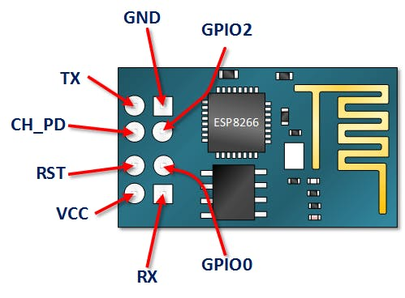
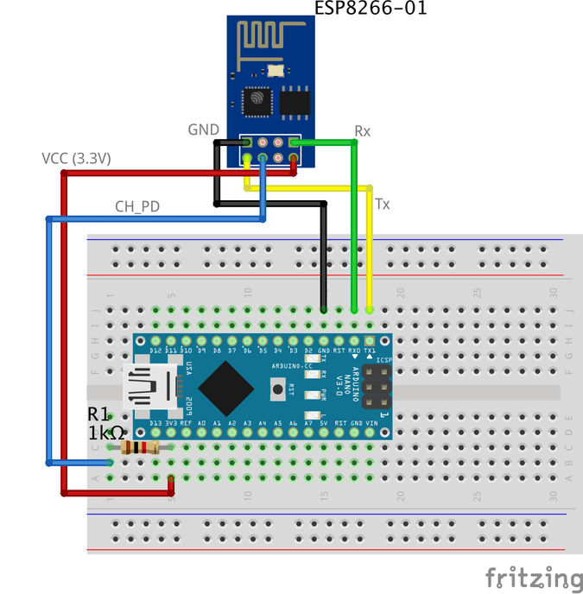
Kalkylepris 20,-.
ESP8266-01 - en av de mest brukte variantene

Strøm
VCC: connect to +3.3V power source. don’t connect it with a 5V source it will get damaged.
- GND: -ve pin, connect it to the ground of your circuit

Seriekommunikasjon mot Arduino:
- Tx: connect to the Rx of the microcontroller(Arduino) to establish serial communication.
- Rx: connect to the Tx of the microcontroller(Arduino) to establish serial communication.

- CH_PD: chip enables pin – Active HIGH. connect it to a logic value HIGH to allow the module to boot up.
- RST: Chip Reset pin – Active LOW, when it pulled LOW it Resets the module.
- GPIO0, GPIO2: General purpose input/output pins.

Programvare på ESP:

Changing the ESP8266-01 communication speed

First step: Upload an empty program to the Arduino board

At this step, we are uploading an empty code to the Arduino board. Just to be sure that there’s nothing is Executing in the background by the Arduino board.
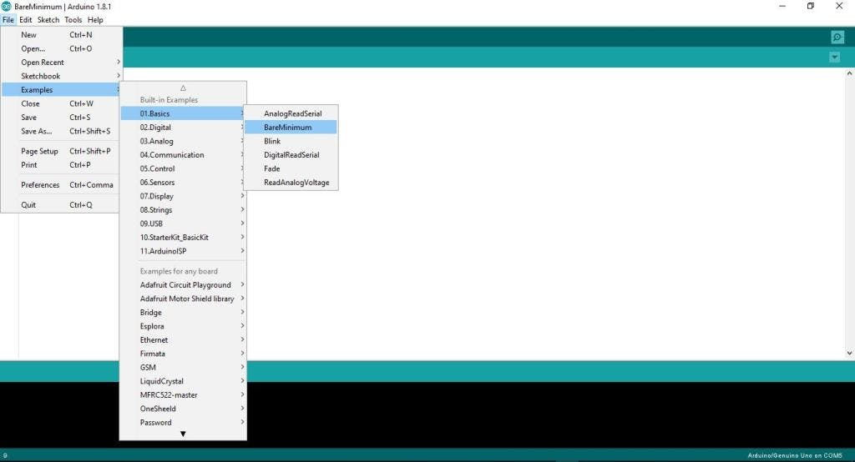

Telenor M2M og IoT:
Tore Larsen
Partner Manager - IoT
Business Partner Sales - M2M and IoT
Telenor Norge
Mobil: +47 90545936
Snarøyveien 30, NO-1331 Fornebu

